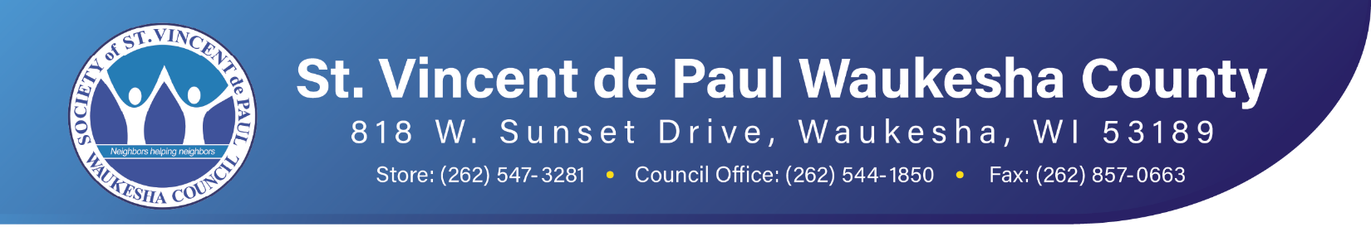
Monthly Quote for Reflection
“Give some time every day, if it is only half an hour, to devotional reading, which is as necessary to the well-ordering of the mind as the hand of the gardener is to prevent the weeds from destroying your favorite plants.”
~ St. Elizabeth Ann Seton
MONTHLY REMINDERS For March 2025
NOVEMBER
S | M | T | W | T | F | S
 |  |  |  |  |  | 1
2 | 3 | 4 | 5 | 6 | 7 | 8
9 | 10 | 11 | 12 | 13 | 14 | 15
16 | 17 | 18 | 19 | 20 | 21 | 22
23 | 24 | 25 | 26 | 27 | 28 | 29
30



Blessings to all of you and your families this Thanksgiving Holiday

Activities This Month
November 2025
3 - St. Bruno
10 - St. James, Muk
17 - St. Mary
24 - St. Joan of Arc

SVdP Meal Program Volunteer Commitment
- 8 conference members/volunteers arrive at 4:50
- 5 gallons of milk (2 white & 3 chocolate)
- 100 desserts of any type (due to higher attendance)
- Contact Peggy Fahl to confirm: Call/text 414-828-6999 or pegfahl@gmail.com

November 4
Understanding Eviction Legal Aid Presentation
Council Meeting Room
6:00pm – 7:30pm
The presenter will be Lillian Cheesman Staff Attorney Legal Aid Society of Milwaukee.
Click HERE to register

Waukesha Council

Opening Doors: SVDP Housing Initiative Update
Keep an eye on your inboxes for the Opening Doors Housing newsletter for the latest information to help your neighbors maintain and obtain housing stability.

Conference Annual Reporting (Due date October 21)
As of 10/31, 17 Conferences have submitted their Conference Annual Report. Thank you. Don’t tarry! Please submit your Conference Annual Reports as soon as possible.

W-9’s – IRS 1099-MISC
Attention all Conference Treasurers: An updated vendor list has been posted on the Member Info section of our website under Conference Officer Forms/Treasurer.

IRS Form 1099 Reporting is for the 2025 calendar year, not the fiscal year. Bonnie needs copies of your W-9’s and tracking reports no later than January 9, 2026. Please send what you have on file now. You can then forward additional W-9’s as they are received to complete the 2025 year.

This information needs to be combined and sent to our accountants, who submit 1099-MISC forms to the IRS on our behalf. Be aware that the tracking form MUST include the Vendor name, address and EIN/SSN number to be processed. Only cumulative payments of $600 and up per vendor needs to be reported.

Programs & Ministries

Jail Ministry News

Project Angel Tree
Conference Presidents, if your conference is participating in the Angel Tree effort this year, please watch your mailbox. We will be mailing the gift tags along with instructions in mid-November. You will have until early December to purchase the gift. Please return your conference's gifts to the St. Dismas Jail Ministry office (818 W. Sunset Dr, Waukesha 53189) starting Monday, December 8 and no later than Friday, December 12. Put all the gifts you purchased together in a bag/box with your conference name clearly labeled on the outside. If you have any questions, please contact Karolyn Krueger at karolynk321@gmail.com or text her at 262-893-8527.

Conference Resources

WE Energies Moratorium
The winter heating disconnection moratorium in Wisconsin became effective on November 1, 2025. At that time, utility companies are prohibited from disconnecting services through April 15, 2026, due to a missed payment for home heating.

Up-to-Date Food Pantry List
In case you receive calls regarding food aid, we have posted an up-to-date food pantry list for Waukesha County. You will find this list on our website in the Get Help section under Community Resources. Please click HERE to be taken to the web page. Scroll down to ‘Food Pantries of Waukesha County’.

Conference and Member Questions and Answers (from the E-Gazette National Newsletter)
Q: Is it allowed, or permitted, for an associate member to “go on a case with an active Vincentian?” Can an associate member take an active part in deciding what should or should not take place with a case once a case has been visited by an active Vincentian and this associate member?

A: If an associate member is allowed to go on home visits it means that the Conference has confidence in their judgment. It would be wrong to take an associate member along on a home visit just to fulfill the two Vincentians rule. Only active members can decide how to assist a neighbor visited.

Index of Conference & Member Q & A
Questions and answers appear in the E-Gazette, the National E-newsletter. Find the full Q&A Index here.
Submit your questions to Pam Hudson Johnson at phudson@svdpusa.org

What’s Ahead
SVdP Meal Program Volunteer Commitment
December 2025
1 - St. John Neumann
8 - St. Charles
15 - St. Jerome
22 - St. Anthony
29 - St. Leonard

