REMINDERS
June 2022
St. Vincent de Paul Waukesha County Monthly Newsletter
JUNE
M | T | W | T | F | S | S
 | 1 | 2 | 3 | 4 | 5 | 6
7 | 8 | 9 | 10 | 11 | 12 | 13
14 | 15 | 16 | 17 | 18 | 19 | 20
21 | 22 | 23 | 24 | 25 | 26 | 27
28 | 29 | 30

S | M | T | W | T | F | S
 |  |  | 1 | 2 | 3 | 4
5 | 6 | 7 | 8 | 9 | 10 | 11
12 | 13 | 15 | 16 | 17 | 18 | 19
19 | 20 | 21 | 22 | 23 | 24 | 25
26 | 27 | 28 | 29 | 30
Monthly Quote for Reflection
“Sickness is not an evil which we should fear, but a most efficacious means of sanctifying our souls. To murmur when God sends it, is to complain of his having done us good.”
~ St. Vincent de Paul
Waukesha Council Office  818 Sunset Drive, Waukesha, WI 53189  Office: 262-544-1850  Store: 262-547-3281  Fax: 262-522-9048  Email: info@svdpwaukesha.com  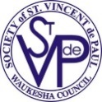  Website: www.stvincentwaukesha.org | Julie McIntyre, Executive Director  Phone: 262-522-3240  jmcintyre@svdpwaukesha.com  Bonnie Pranger, Executive Assistant  Phone: 262-349-9027  bpranger@svdpwaukesha.com  Brenda Szpot, Accountant  Phone: 262-522-3241  bszpot@svdpwaukesha.com

To Use the Table of Contents:
Hold your mouse over the topic of interest
and press Ctrl + Click to jump to that section.
Contents
Activities This Month 2
Waukesha Council 2
Programs & Ministries 3
Getting Ahead 3
Stores 3
Conference Resources 3
What’s Ahead 4
Petitions 4

Activities This Month
June 2022
6 - St. Catherine
13 - St. John Vianney
20 - St. Jerome Mini-V’s
27 - St. Dominic
July 4 - Volunteers Needed
SVdP Meal Program Volunteer Commitment
It is asked that 5-6 conference members arrive at 4:50 with 4 gallons of milk and 80 desserts. Bars and cookies are best. The commitment is comprised of serving the meal with cleanup afterwards, normally completed by 6:30. Thank you all for your great support of the SVdP Monday meal program. Please contact Peggy Fahl to confirm your assignment and/or if you have any questions. Call/text 414-828-6999 or email pegfahl@gmail.com

June
Achieving the Mission
This session will not be held this month. Date to be determined.

June 20
Summer Lunch Program Begins
Conference Commitments for June
20 – 21 St. Joseph-Big Bend
22 – 23 St. Luke
27 – 28 St. Teresa of Calcutta
29 – 30 St. John Vianney

June 23-25
NCR Meeting
Marriott Milwaukee West, Waukesha
ITS HERE! We’ve been talking about this ‘big’ meeting for months! It has finally arrived! It is roughly every 10 years this meeting wheels around to Waukesha (or Milwaukee). What a great opportunity to see firsthand what this meeting is all about! As stated many times, regional meetings are targeted specifically for members and conferences: the workshops, keynotes; night on the town; socializing; banquet! It is hoped you have already registered!

July 4 Meal Service
Peggy is looking for 4-5 individuals that are willing to serve at the Monday, July 4th meal. Please contact Peggy if you would like to share your holiday with those less fortunate. See email and phone above.

Waukesha Council
Ozanam Medallion
At the Archdiocesan Spring General Meeting on 5/15/22, the Ozanam Medallion was presented to a married couple and, not as common, a conference. We are proud to announce that his honor was awarded to our own St. Mary, Waukesha Conference.
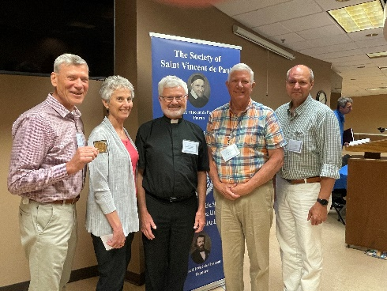

Best Practice Session
Held May 24, 2022 Conference Presidents chose 4 topics; Recruitment, If and how to help people in moving situations; Conference Record Keeping Practices; Delegating Responsibilities. You will find a document outlining the discussion with bullet points.

Programs & Ministries
Summer Lunch Program
The Summer Lunch Program has undergone some changes. Due to the low numbers immediately after school lets out, the week of the July 4th holiday, and after the Waukesha Parks, Recreation and Forestry Playground Program ends, it was decided the Summer Lunch Program would run concurrent with the 6-week WPRF summer program, from June 20 to Aug 4. Each of the six weeks was divided in half providing 12 conferences the opportunity to provide lunches. The WPRF program holds field trips on Fridays so the conferences serving on Thursdays will bring additional lunches for the Parks staff to hand out the following day.

It might help get word out to those who need the lunch program most if conferences within Waukesha’s borders would distribute a copy of the Summer Lunch flyer on their Home Visits. The flyer is attached to these Reminders but if you need a large amount, just let Julie or Bonnie know and we will be happy to print up a supply for you.

Getting Ahead
Happy Summer from the Getting Ahead team! We know summer is a busy season for many, and that goes for the GA team too.

We would like to invite you to the bridging seminar in our new office space, on Wednesday June 15th at 11am. Join us for a good discussion as we get a light introduction in the three economic classes and how that shapes and impacts our community. The seminar includes lunch & materials and is free to anyone who wants to join. All you need to do is register at gettingahead@svdpwaukesha.com.

We hope to see you there!

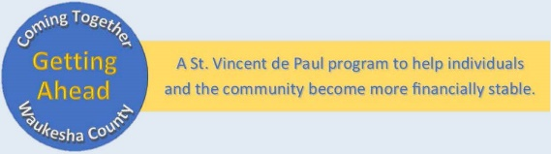
Jodie LaChapelle
Getting Ahead Program Director
262-547-0654 office
262-765-0744 cell phone
jlachapelle@svdpwaukesha.com

Ending Poverty – One person, One neighborhood, One community at a time.

Stores

Store contact information:
Waukesha: John Erdmann, 262-547-3281, jerdmann@svdpwaukesha.com
Oconomowoc: Chandler Papa, 262-569-0761, cpapa@svdpwaukesha.com
Pewaukee: Ryan Bay, 414-659-0129, rbay@svdpwaukesha.com
SVdP Sunday Scheduler/Truck Driver: Jason Schmittinger, 262-720-0386, jschmittinger@svdpwaukesha.com
Director of Marketing & Development: Rod Colburn
rcolburn@svdpwaukesha.comD MINISTRIES

Conference Resources

Conference and Member Questions and Answers (from the E-Gazette National Newsletter)
Q: What is the National Council’s position on having co-Presidents within a Conference? I cannot find anything in the Manual or the Rule that prohibits it.

A: The National Council’s official position is that co-Presidents in a Conference is not recommended. Too many problems occur with co-Presidents and it is difficult for Vincentian members to know who to go to for issues and/or concerns that may arise. This is why we have Vice-Presidents. One President per Conference is sufficient.

Index of Conference & Member Q & A
Conference and Member questions and answers appear in the E-Gazette, the National E-newsletter. Each month questions and answers are chosen for the monthly REMINDERS. The National office has put together the collection of all Questions & Answers since this practice started! Index of Conf & Member Q&A's
Pam Hudson, National Director of Governance & Membership Services, phudson@svdpusa.org

What’s Ahead

July 2022 | August 2022
4 - VOLUNTEERS NEEDED | 1 - St. Mary, Wauk
11 - St. Charles | 8 - St. Anthony, Pew
18 - St. James, Muk | 15 - St. Jerome & Mini-V’s
25 - St. Bruno | 22 - St. Leonard
 | 29 - St. Joan of Arc

SVDP Meal Program Volunteer Commitment
Contact Peggy Fahl before your week for up-to-date information on serving needs. Call/text at
414-828-6999 or email pegfahl@gmail.com

July 4 Meal Service
A volunteer staff is again needed for the July 4th Meal Program. 4 to 5 Individuals are asked to come forward.

Summer Lunch Program
Conference Commitments for July
11 – 12 St. James, Muk
13 – 14 St. Theresa
18 – 19 St. Dominic
20 – 21 St. Charles
25 – 26 St. Charles Outreach Services
27 – 28 St. Anthony, Pew

Conference Commitments for August
1 – 2 St. Leonard
3 – 4 St. William

July 25
Quarterly Membership Meeting
Waukesha Council Meeting Room

August 15
5th Annual Golf Outing
Broadlands Golf Club

August 8 – 19
Back to School Program
St. William Gym

Petitions

Prayers for Health
Jo Camacho, St. Joseph Conference

Rest in Peace
Kathy DeCleene, member St. Joseph, Big Bend

